Jenkins 04 second document task (02-06)
Task
setup a Jenkins CICD pipeline using Declarative pipeline using
Feature-1.1 branch.
https://github.com/betawins/sabear_simplecutomerapp/tree/feature-1.1
- stages:
- Git Clone
- Sonarqube Integra on
- Maven Compila on
- Nexus Ar factory
- Slack No fica on
- Deploy On tomcat
2. Configure Global Tools
Manage Jenkins → Global Tool Configura on
- Maven:
- Name: MVN_HOME (matches your Jenkinsfile)
- Install automa cally or point to /usr/share/maven
- SonarQube Scanner:
- Name: sonar_scanner (matches your Jenkinsfile)
- Provide installa on path or let Jenkins auto-install
3. Add Server Integra ons a) SonarQube • Go to Manage Jenkins → Configure System → SonarQube servers o Name: sonarqube-server (matches your Jenkinsfile) o Add Server URL (e.g., h p://:9000) o Add authen ca on token (create in SonarQube UI → My Account → Security → Tokens)
.Create a New Pipeline Job 1. Open Jenkins dashboard → New Item. 2. Enter a job name (e.g., simple-customerapp-pipeline). 3. Select Pipeline → Click OK.

First we need create one piple line in my case written piple line select an item name pipeline pipeline
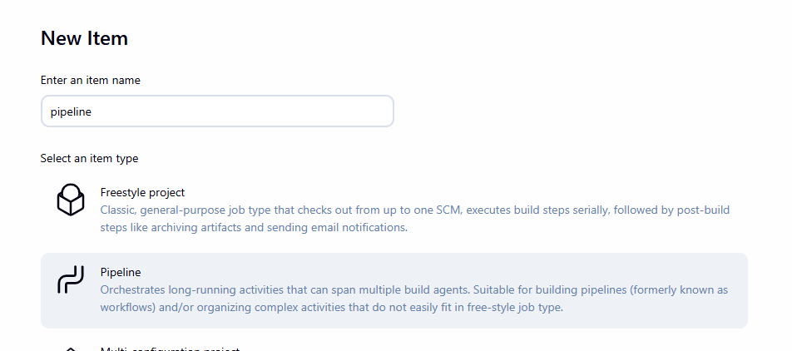
Now paste pipeline {
agent any
tools {
jdk 'jdk21'
maven 'MVN_HOME'
}
stages {
stage('Git Clone') {
steps {
git 'https://github.com/betawins/sabear_simplecutomerapp.git'
}
}
stage('SonarQube Analysis') {
environment {
JAVA_HOME = '/opt/apache-maven-3.9.12'
PATH = "$SONARQUBE_HOME/bin:$PATH"
}
steps {
withSonarQubeEnv('SonarQube') {
sh '''
mvn clean verify \
org.sonarsource.scanner.maven:sonar-maven-plugin:sonar \
-Dsonar.projectKey=SimpleCustomerApp \
-Dsonar.projectName=SimpleCustomerApp
'''
}
}
}
stage('Maven Build') {
steps {
sh 'mvn clean package'
}
}
stage('Nexus Upload') {
steps {
nexusArtifactUploader(
nexusVersion: 'nexus3',
protocol: 'http',
nexusUrl: '3.86.213.189:8081',
repository: 'simple-customer-app',
credentialsId: 'nexus-token',
groupId: 'com.javatpoint',
version: "${BUILD_NUMBER}-SNAPSHOT",
artifacts: [
[artifactId: 'SimpleCustomerApp', type: 'war', file: 'target/SimpleCustomerApp-${BUILD_NUMBER}-SNAPSHOT.war']
]
)
}
}
stage('Deploy on Tomcat') {
steps {
sh '''
scp -i /var/lib/jenkins/.ssh/aws-key.pem \
-o StrictHostKeyChecking=no \
target/SimpleCustomerApp-${BUILD_NUMBER}-SNAPSHOT.war \
ec2-user@3.91.234.223:/opt/apache-tomcat-9.0.113/webapps/
'''
}
}
}
} your script inside in it also make sure url java mast match

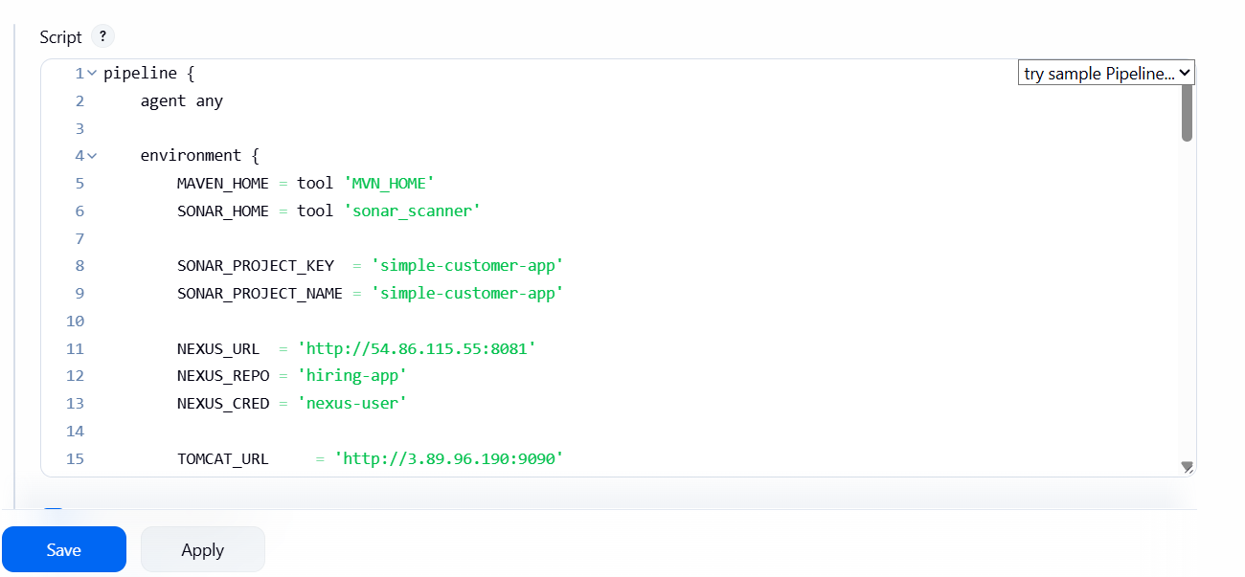
That’s it we created our pipeline
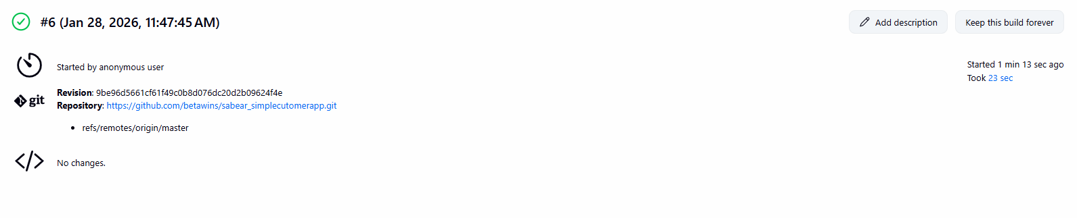
Console output
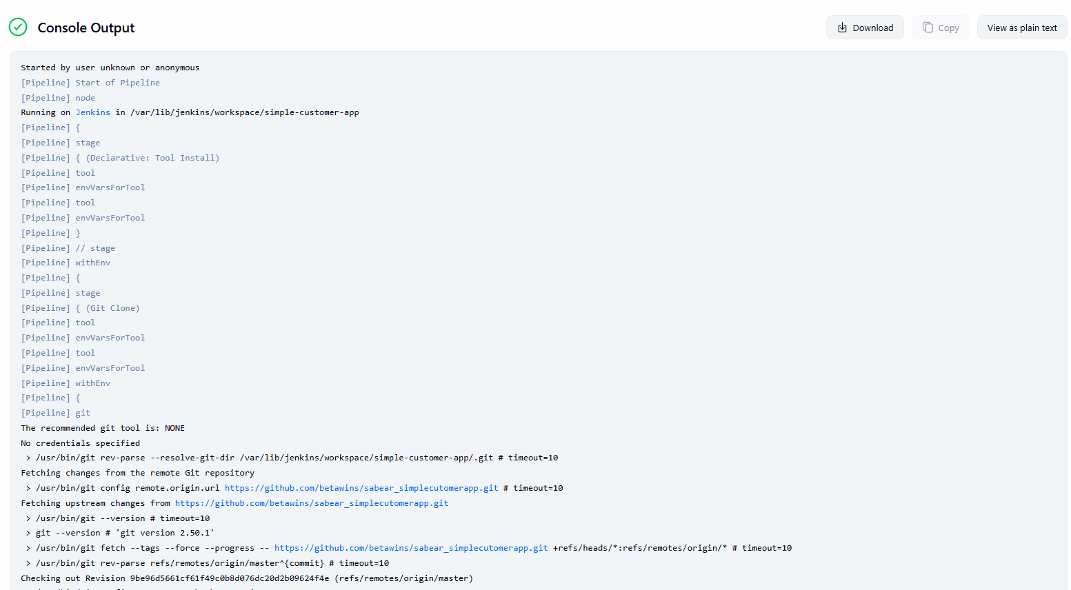
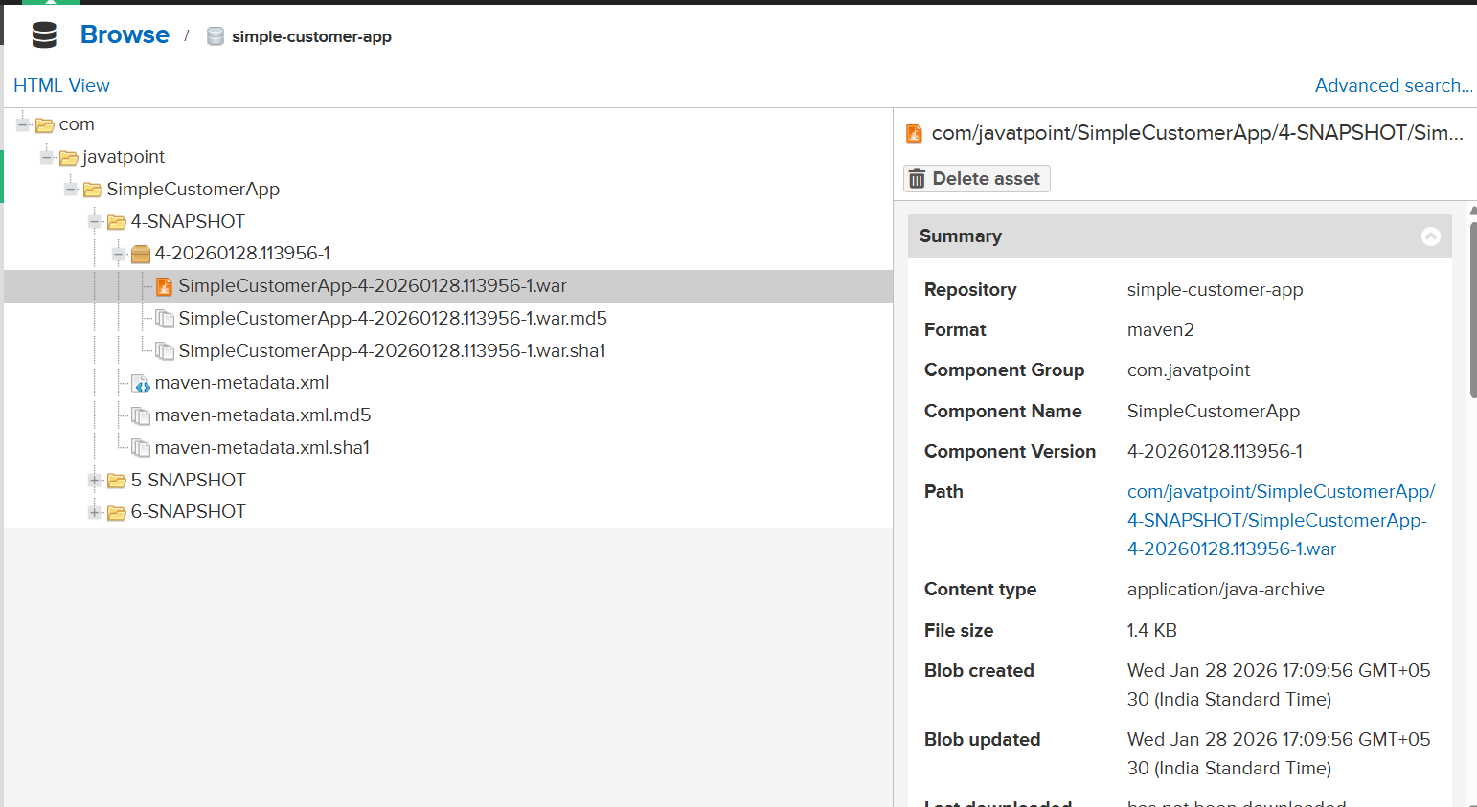
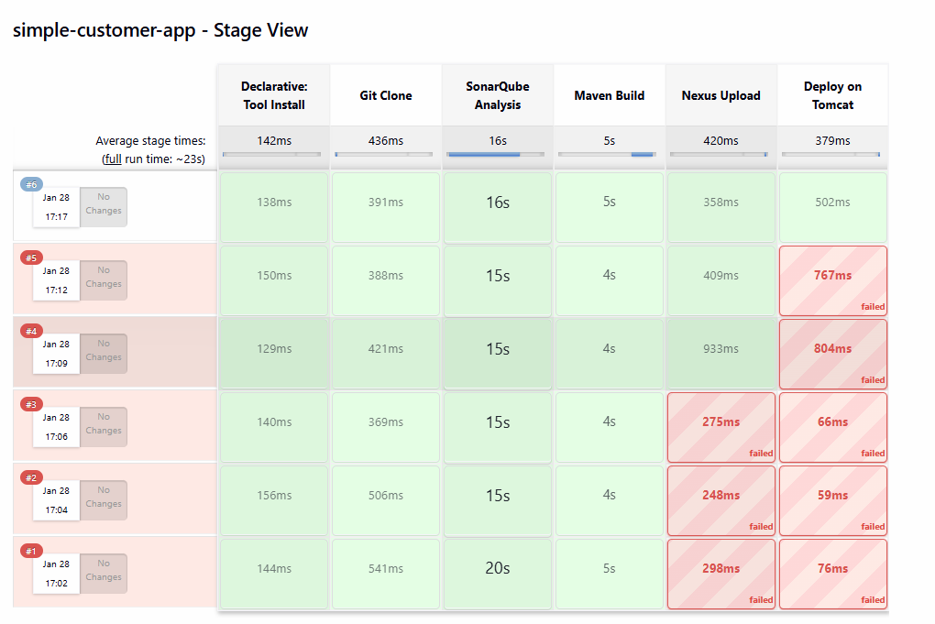
Slack notification
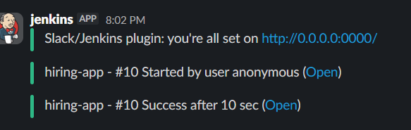

3. Setup a Jenkins CICD pipeline using Scripted pipeline using feature-1.1 branch. https://github.com/betawins/ sabear_simplecutomerapp/tree/feature-1.1
stages:
Git Clone
SonarQube Integration
Maven Compilation
Nexus Artifactory
Slack Notification
Deploy On tomcat
now login to your Jenkins click on new item enter any name like my scripted pipeline or any in my case I have written scripted-pipeline and select pipeline that’s it click ok
stages:
Git Clone
SonarQube Integration
Maven Compilation
Nexus Artifactory
Slack Notification
Deploy On tomcat
node {

// Tools
def jdkHome = tool 'jdk21'
def mvnHome = tool 'MVN_HOME'
env.PATH = "${jdkHome}/bin:${mvnHome}/bin:${env.PATH}"

stage('Git Clone') {
git 'https://github.com/betawins/sabear_simplecutomerapp.git'
}

stage('SonarQube Analysis') {
withSonarQubeEnv('SonarQube') {
sh '''
mvn clean verify \
org.sonarsource.scanner.maven:sonar-maven-plugin:sonar \
-Dsonar.projectKey=SimpleCustomerApp \
-Dsonar.projectName=SimpleCustomerApp
'''
}
}

stage('Maven Build') {
sh 'mvn clean package'
}

stage('Nexus Upload') {
nexusArtifactUploader(
nexusVersion: 'nexus3',
protocol: 'http',
nexusUrl: '13.221.102.16:8081',
repository: 'simple-customer-app',
credentialsId: 'nexus-token',
groupId: 'com.javatpoint',
version: "${BUILD_NUMBER}-SNAPSHOT",
artifacts: [
[
artifactId: 'SimpleCustomerApp',
type: 'war',
file: "target/SimpleCustomerApp-${BUILD_NUMBER}-SNAPSHOT.war"
]
]
)
}

stage('Deploy on Tomcat') {
sh """
scp -i /var/lib/jenkins/.ssh/aws-key.pem \
-o StrictHostKeyChecking=no \
target/SimpleCustomerApp-${BUILD_NUMBER}-SNAPSHOT.war \
ec2-user@54.92.220.99:/opt/apache-tomcat-9.0.113/webapps/
"""
}
}
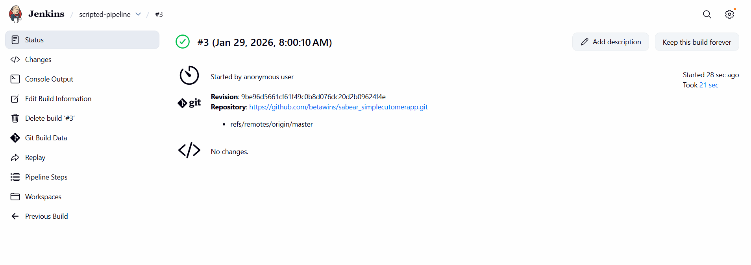
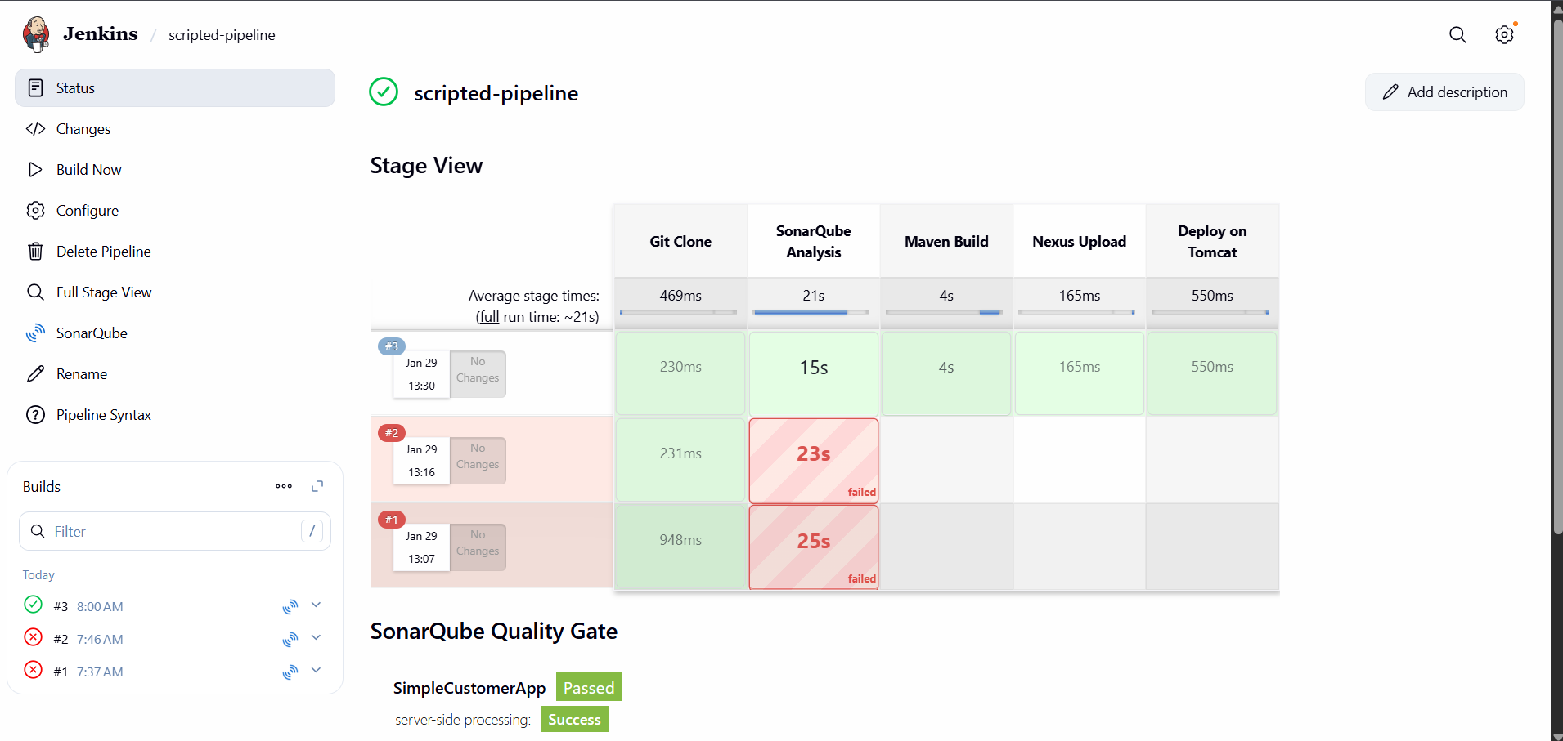
4. Write sample skeleton of pipelines.
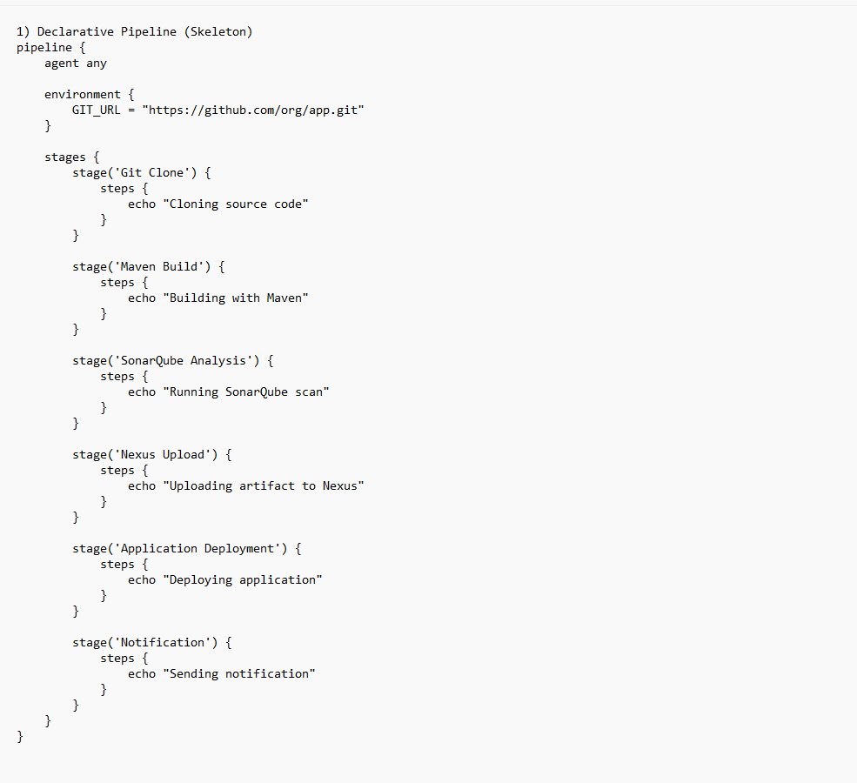
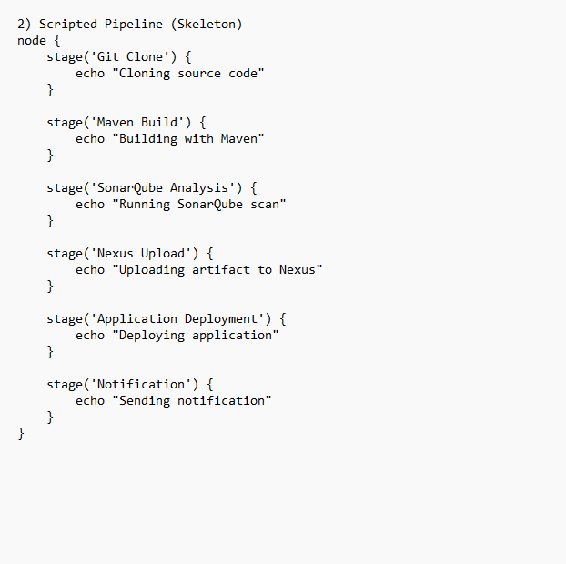
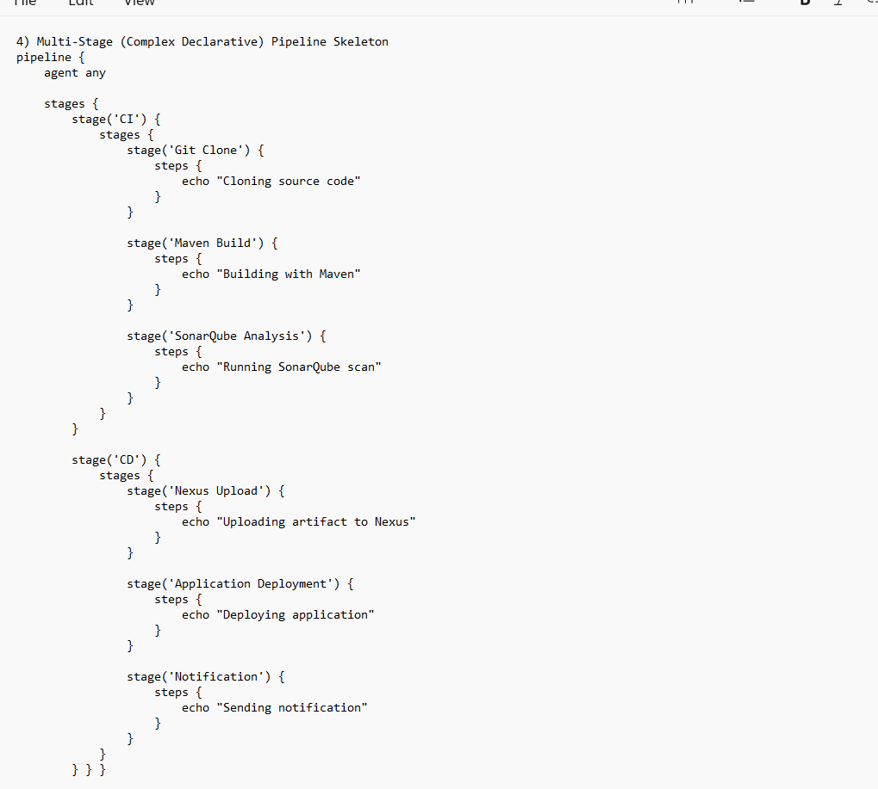

5. Create a parameterized job in Jenkins.
https://github.com/betawins/spring3-mvc-maven-xml-hello-world-1.git
first we need create new job click on new item
now give your job like in our case we given parameterized job then give it free-style project that’s now click on ok

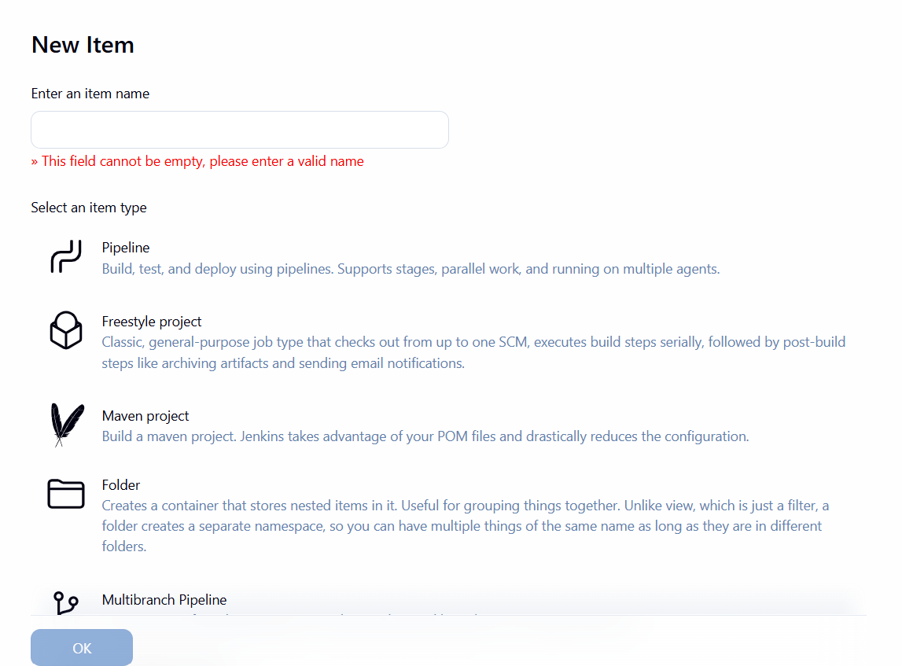
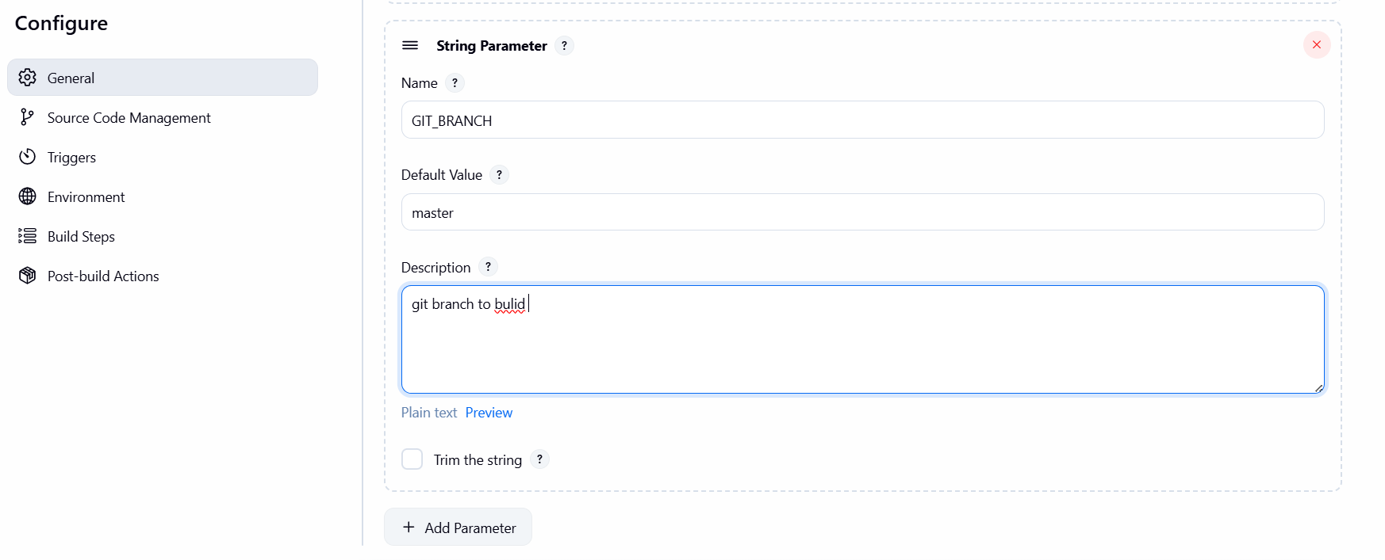
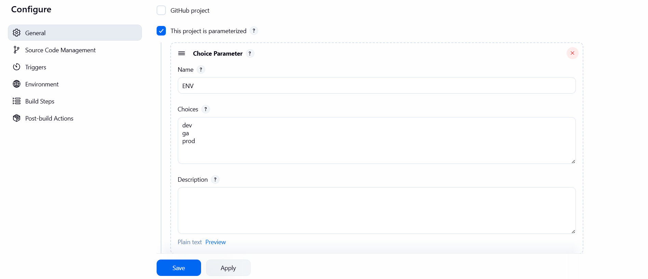


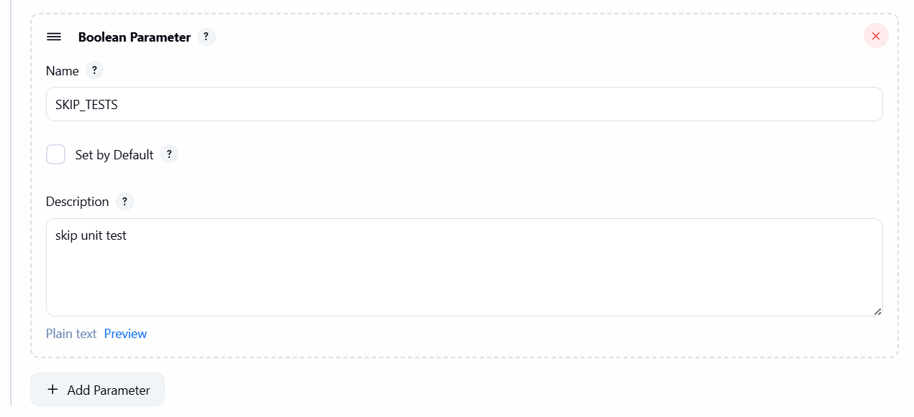
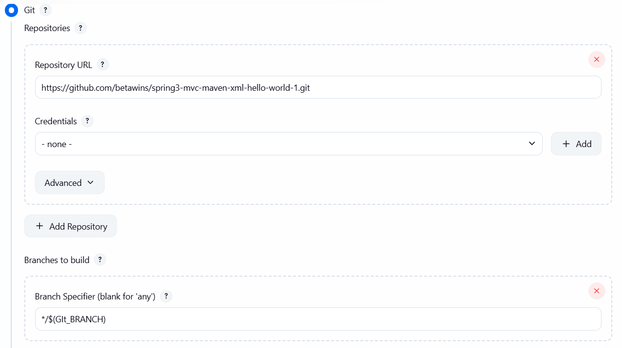

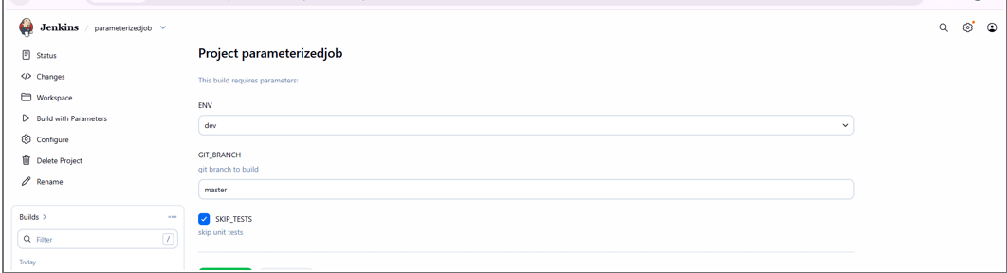
6. Setup one slave machine for Jenkins.
Task Title
Setup One Jenkins Slave (Agent) Machine on AWS EC2

Objective
To configure a Jenkins slave (agent) machine on AWS EC2 and connect it with the Jenkins master using SSH, enabling builds to run on the agent node instead of the master. This improves performance, scalability, and separation of workloads.

Prerequisites
- Jenkins Master already installed and running
- AWS EC2 instance (Amazon Linux 2023) created for Slave
- Public IP of Slave instance
- Java installed on Slave (java-17-amazon-corretto)
- SSH access between Jenkins Master and Slave
- Jenkins user available on Master (/var/lib/jenkins)
- Network access:
  - Port 22 open between Master and Slave
  - Jenkins UI accessible in browser

Step-by-Step Implementation
1. Launch EC2 Instance for Slave
- Create an EC2 instance (Amazon Linux 2023).
- Note down:
  - Public IP: 13.127.24.194
  - Private IP: 172.31.38.235
2. Install Java on Slave
sudo su -
dnf install java-17-amazon-corretto -y
java -version
3. Generate SSH Key on Slave
ssh-keygen -t rsa
This creates:
- /root/.ssh/id_rsa
- /root/.ssh/id_rsa.pub
4. Copy Public Key to Jenkins Master
On Slave:
cat /root/.ssh/id_rsa.pub
Copy the key.
On Jenkins Master:
sudo su -
mkdir -p /var/lib/jenkins/.ssh
cd /var/lib/jenkins/.ssh
vi authorized_keys # paste the public key
chmod 700 /var/lib/jenkins/.ssh
chmod 600 authorized_keys
chown -R jenkins:jenkins /var/lib/jenkins/.ssh
Add Slave host to known_hosts:
ssh-keyscan -H 172.31.38.235 >> /var/lib/jenkins/.ssh/known_hosts
chown jenkins:jenkins /var/lib/jenkins/.ssh/known_hosts
chmod 700 /var/lib/jenkins/.ssh/known_hosts
5. Configure Node in Jenkins UI
- Go to Manage Jenkins → Nodes → New Node
- Enter name: slave-1
- Select: Permanent Agent
Configure:
- Number of executors: 2
- Remote root directory: /home/ec2-user
- Labels: java
- Usage: Only build jobs with label expressions matching this node
- Launch method: Launch agent via SSH
- Host: 172.31.38.235
- Credentials: ec2-user (SSH)
- Host Key Verification Strategy: Non verifying
Click Save.
6. Verify Node Status
Go to Manage Jenkins → Nodes.
- slave-1 should appear Online.
- Architecture: Linux (amd64)
- Response time visible
7. Run a Job on Slave
- Create a Jenkins job
- Configure it to run on label: java
- Build the job
- Console output shows:
- Running on slave-1 (java) in workspace /home/ec2-user/workspace/first_java
- Finished: SUCCESS

Validation Steps
- Jenkins Nodes page shows slave-1 as Online
- SSH connection succeeds from Jenkins Master to Slave
- Job runs on slave-1
- Workspace is created under /home/ec2-user/workspace/
- Console output ends with Finished: SUCCESS
- 